**TASK 03**

**Name: Abdullah Butt** **Roll Number: 018**

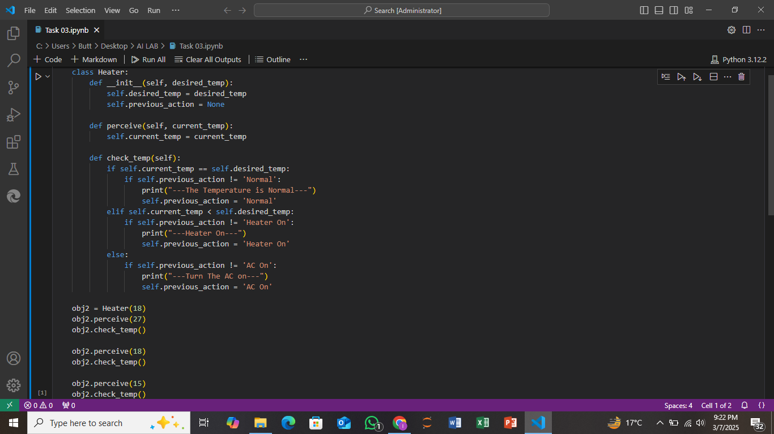

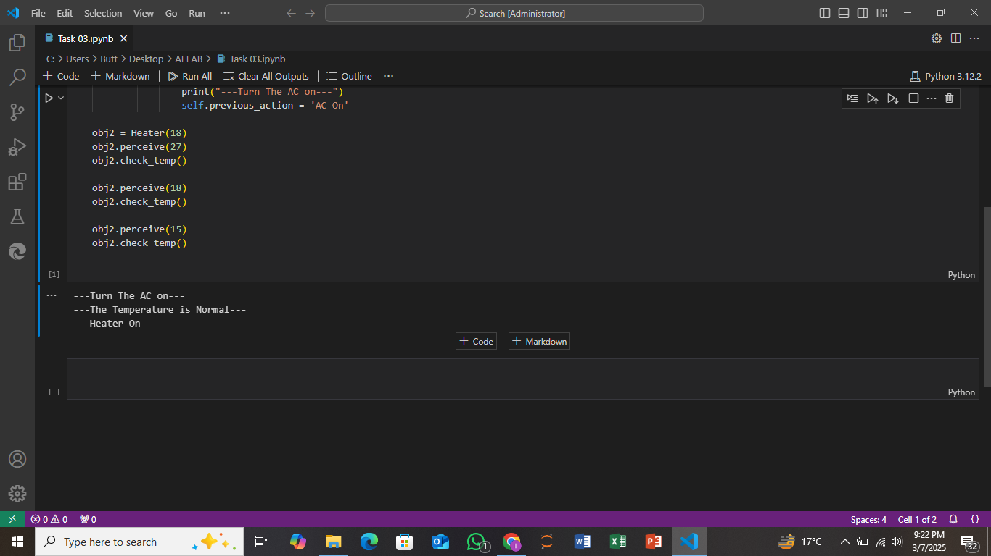

**Explanation:**

The Heater class is designed to control the temperature of a room. It has an attribute desired_temp that stores the temperature you want to maintain. The __init__ method sets the desired temperature and initializes the previous action (like whether the heater or AC was on). The perceive method updates the current temperature of the room. The check_temp method compares the current temperature to the desired temperature and decides what action to take: if the temperature is normal, it does nothing; if it's too low, it turns the heater on; if it's too high, it turns the AC on. It also ensures it only prints an action if it’s different from the previous one to avoid repeated messages. The code then creates an object of this class and tests it by setting different current temperatures.